37.75: a)
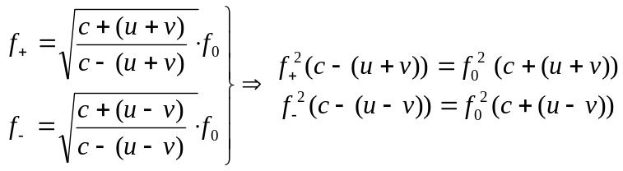
where is the velocity of the center of mass and is the orbital velocity.
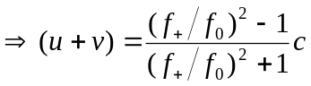 and 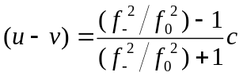
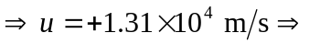moving toward at 13.1 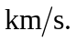
b) 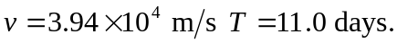
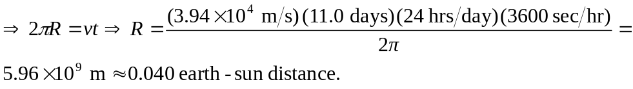
Also the gravitational force between them (a distance of 2R) must equal the centripetal force from the center of mass:
